Car Seat Safety for Preterm or Low Birth Weight Babies
Is Different from Car Seat Safety for Term Babies.
You may need to modify your car safety seat to make sure it is safe
for your preterm or low birth weight baby.
We encourage you to buy a car seat for infants > 4lbs if you are taking home a preterm baby.
You can find a complete list of car seats at www.HealthyChildren.org
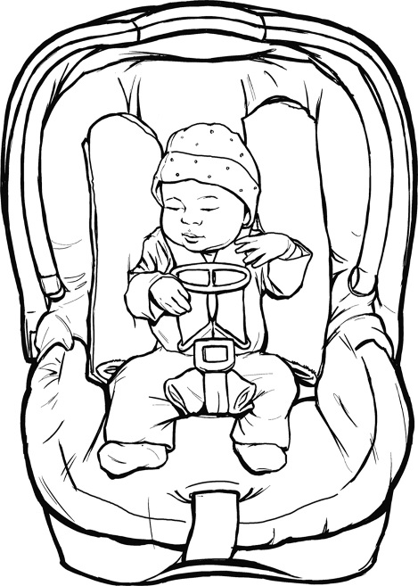
Your baby’s nurse will give you more information.

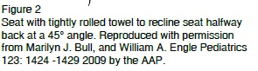
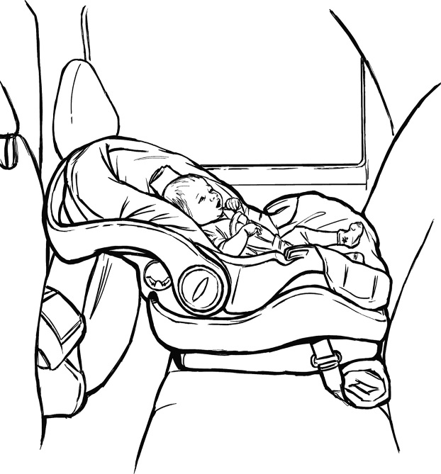
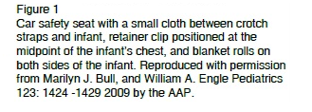
Kaiser Permanente recommends that an adult be seated in the back seat next to infant.
infants should spend as little time as possible in a car seat.
The car safety seat must face the back end of the car.
The car safety seat should recline at a 45° angle.

Refer to your car owner’s manual to determine proper installation of your car safety seat.
Retainer clip positioned in the middle of the baby’s chest. FOR ALL BABIES.
Blanket rolls on both sides of the infant, IF THEY ARE NECESSARY.
A small rolled diaper or blanket between the crotch strap and baby may reduce sliding.

